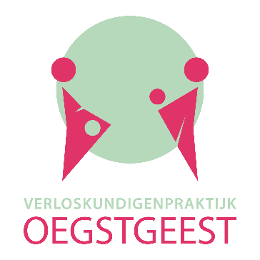

CONSENT FORM DATA PROCESSING
Our midwifery practice is extremely careful in dealing with personal data of our patients. We adhere to the rules and laws of the GDPR (General Data Protection Regulation). Without your consent to make (careful) use of your personal data, we cannot treat you at our midwifery practice. More information about which data it concerns, what we do with personal data and what your rights are, is written in the privacy statement on our website.
Your consent deals with a number of situations:
- The processing of your personal data in your patient-file;
- supplying your personal data to your insurance (concerning the expense account);
- supplying your personal data to other caregivers if necessary: the gynecologist, your GP, the ultrasound centre (verloskundig centrum de Poort), your supplier of maternity care (kraamzorg) and the centre for youth care (Centrum voor Jeugd en Gezin);
- supplying your personal data to third parties, like Peridos¹, Praeventis² and Perinatale Registratie Nederland³;
- when you send/give us your birth announcement, we like to display it at our practice. When you don’t want your name and/or address visible for other visitors, you are responsible to make these data unrecognizable.
□ I, hereby, give Verloskundigenpraktijk Oegstgeest permission to process personal data regarding my health and my pregnancy in order they can provide me midwifery care during the pregnancy, delivery and postpartum period.
Date
Birth name
Date of birth
Signature

- Peridos is a national system where data of prenatal screening is recorded in order to improve and optimize the quality and the process of screening. Prenatal screening must comply with the Population Screening Act.
- Data from your blood results and the results of the heel prick test are saved and monitored in the national database of Praeventis, part of the RIVM (Rijksinstituut voor Volksgezondheid en Milieu).
- Your data is recorded nationally in the database Perined (Prenatal registration in the Netherlands) in order to do statistical research and to improve the quality of perinatal care in the Netherlands in accordance with the data collection obligation imposed by Zorginstituut Nederland (ZiN).

